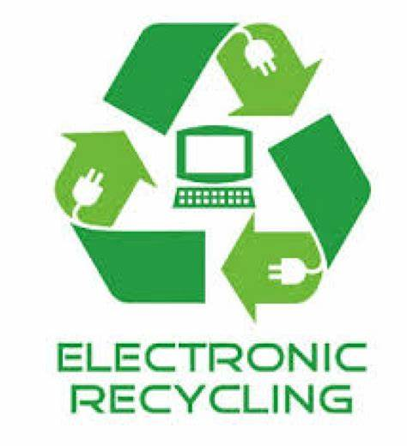

ELECTRONIC RECYCLING
EVENT

SATURDAY OCTOBER 24th, 2026
9 AM TO NOON
SOUTH SIDE OF VILLAGE SQUARE (Enter on Lincoln St.)
$10 PER DROP-OFF
OPEN TO ALL VILLAGE OF PAWNEE RESIDENTS AND BUSINESSES
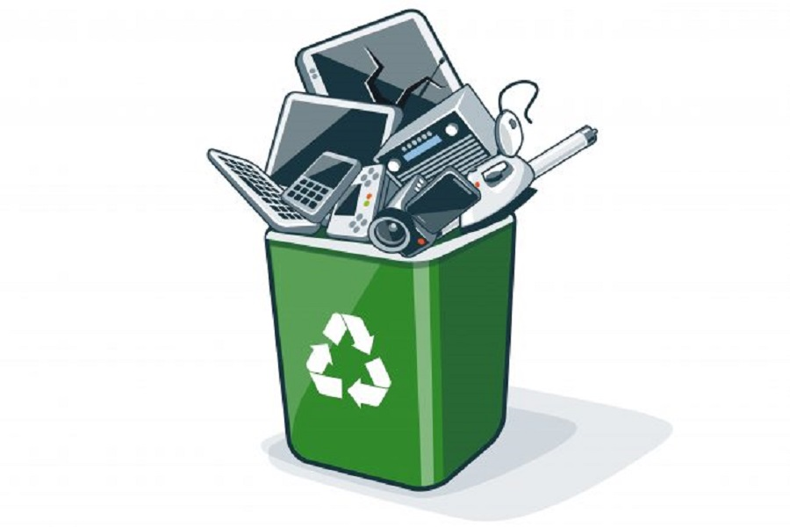
Accepted Items (Including, but not limited to):
CRT, Projection, Plasma, Flatscreen TVs and Monitors
Computers, Printers, Cables and Peripherals
Fax Machines, Scanners and Receivers
Home Electronics, Humidifiers, Blenders, Toasters, etc
Video Game Consoles, DVD players, VCRs, Stereos
Metal Office Furniture, Minifridges, De-humidifiers
Lead Acid Batteries

WILL NOT ACCEPT (Including, but not limited to):
- Non-Electronics - Smoke/CO Detectors
- Hazardous, Flammable or Radioactive Materials - Lightbulbs
- DVDs, VHSs, CDs, Cassettes - Medications

